Google Workspace Proposal

ENCS 4201

March 19th, 2021

Table of Contents

Introduction 3

Purpose 3

Results 4

Selection Justification 6

Glossary 7

References 7

# Introduction

This document is a proposal recommending the use and implementation of Google Workspace within the company of Wayne Industries. This proposal is intended for internal company use and will be the basis of reference when considering office productivity application products. This document will cover the many products offered by Google Workspace and how these offerings will meet the needs of Wayne Industries’ business and operation functions.



# Purpose

As the company expands and becomes more global, our needs are changing and the requirement for online/cloud-based office productivity applications is vital to our business functions. Our current applications in place are host-based and require software to be manually downloaded to each machine. This is time consuming and requires physical access to the host machine to use. Upper management has requested we research a possible software provider that will solve this problem. The best choice will be the one that has constant online availability, cloud-based sharing and storage, security features, and multiple applications that allow word processing, spreadsheets, e-mail, presentations, etc. all at a reasonable cost with multiple payment options to allow us to continue to grow and expand operations globally.

# Results



As most of our employees are mobile and require remote access, we have decided that a cloud-based and online solution would be best. We have investigated Google Workspace as a possible choice of software provider. Google Workspace includes multiple buying options of $7.50, $15.60, and $23.40 per month along with an Enterprise option which requires contacting Google directly for pricing options. Each payment plan has specific elements and options available with the more expensive options being specific to companies and higher volume needs. (Options listed below).

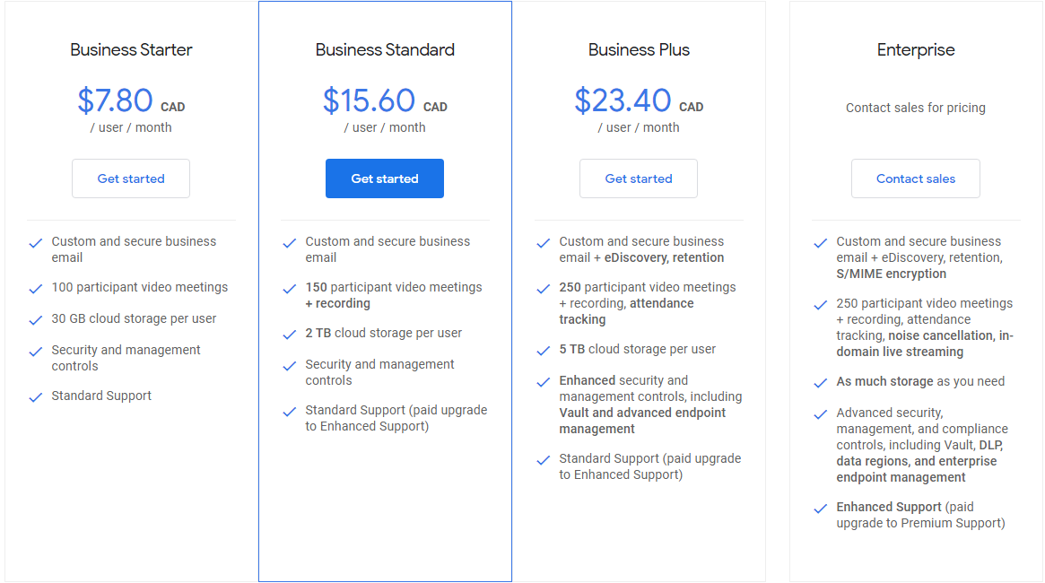

Google Workplace has a large catalog of available applications used for video conference meetings, document writing, presentations, spreadsheets, data storage, calendar, e-mail, website building, surveys, chat message, and security options among a few. (More application options listed below). Google Docs provides word processing (like Microsoft Word) and has very similar features (ideal for every department). Sheets is the equivalent to Excel and is great for creating spreadsheets and accounting information (ideal for accounting and payroll). Slides is like Powerpoint and allows slides to be created for presentations (ideal for management and sales). Google Drive is the main cloud storage for Google applications and depending on the payment subscription you can have 30GB, 2TB, 5TB, or Unlimited storage space per user.

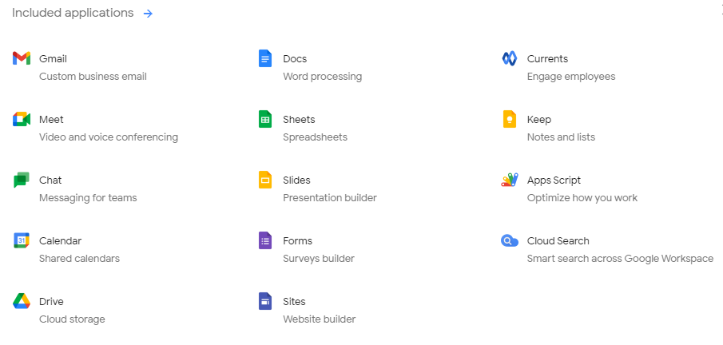

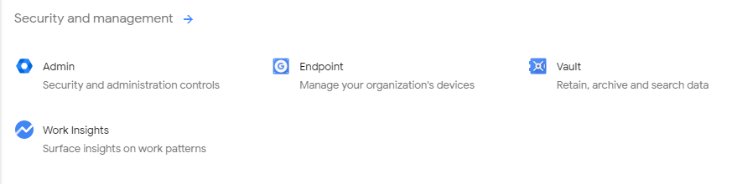

Google Workspace is also a highly available online application provider that does not require the applications to be directly installed on host machines, and all documents, slides, spreadsheets, etc. are saved in cloud storage through Google servers (Google Drive). The security features are also a benefit as the information transferred throughout the company and its operations need to be secure, available, and safe from tampering or accidental loss. There is also a lot of functionality for administration to adjust, maintain, and manage the application suite for the company.

# Selection Justification

Google Workspace is the best choice for our operations as it provides all the applications we require, online cloud-based storage, high-availability, confidentiality, and integrity of information through its many security applications as well. The application suite also has the infrastructure and backing of a very large and global company and we can trust that their services and support will be available 24/7 and problems will be solved in a timely manner. The recommended payment plan would be to do the Business Plus ($23.40) or the Enterprise (varied price) options. We can always start off with the Business Plus plan to test and can always upgrade to the Enterprise package if we require more storage and endpoint management if employees begin to work more remotely (due to travel or pandemic). Google Workspace will ensure that our employees are able to complete work from anywhere and that data and storage will be constantly available, and this will also cut down on overhead costs as we can implement BYOD at the company. This will ensure that our business operations are uninterrupted and we are able to expand operations without needing to alter our applications.

# Glossary

**Application:** A program that provides a specific function.

**Application Suite:** A collection of multiple applications.

**BYOD:** Bring Your Own Devices

**Cloud-Based Storage:** Storage that is stored in datacentres off-site.

**Confidentiality:** Data transmitted is kept secret and is unable to be seen by others.

**Data Integrity:** The contents of data being transmitted is untampered and not altered.

**Endpoint:** Any device that connects to a network.

**High-Availability:** Data is always able to be accessed independent of physical location.

**Host Machine:** A user’s personal computer.

**Non-Repudiation:** A message received can be guaranteed that it came from the person it says it came from.

# References

Google.ca. n.d. Retrieved from: <https://workspace.google.com/intl/en_ca/>